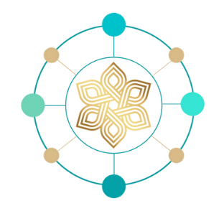

*Dr Jutta Lenz - Wellbeing Coaching*

QUESTIONNAIRE

The goal of this exercise is to get into a self-reflective mood and understand yourself better. Answer this short self-evaluation as a foundation for a first free consultation session with me.

You are welcome to save or scan your answers and share your questionnaire results with me, this is not obligatory though.

Book your free consultation by emailing me at [dr.jutta.lenz@gmail.com.](mailto:dr.jutta.lenz@gmail.com)

Q: Do I suffer from fatigue chronic anxiety, a history of trauma, or ongoing emotional dysregulation?

A:

Q: Do I desire to learn how to live a happier and more harmonious life?

A:

Q: Is my sympathetic nervous system arousal impacting my healing?

A:

Q: What are my life accomplishments up to this point?

A:

Q: What am I content with? What should be improved?

A:

## 1



Q: What life phase am I in at the moment?

# A:

Q: Which areas of my life am I happy with?

A:

Q: Which areas of my life would I like to transform?

A:

Q: How is my work situation?

A:

Q: Do I see new possibilities for my future?

A:

Q: Which people in my environment support me?

A:

Q: Which people prevent me from doing things that I would like to do?

A:

## 2



Q: Who gives me strength? Who saps my energy?

# A:

Q: Does my life partner support my development?

A:

Q: Who are my true friends?

A:

Q: What is the vision for my life?

A:

Q: What are my desires and goals?

A:

Q: What do I definitely want to change?

A:

Q: In which situations does my body react positively?

A:

## 3



Q: What is my current state of mind?

# A:

Q: What would I like to eliminate from my life?

A:

Q: What is it that I truly want and desire?

A:

Q: What are your main realisations after answering these questions?

A:

If you are interested to learn more about yourself and how you can develop and transform your life, get in touch with me via email at [dr.jutta.lenz@gmail.com.](mailto:dr.jutta.lenz@gmail.com)

You are welcome to save or scan your answers and share your questionnaire results with me, this is not obligatory though. All information and our session is strictly private and confidential.

I look forward to connecting with you.

Jutta

4